STEP STEP INSTALL SQL SERVER 2008 R2 EXPRESS

1. Choose the Bit on your computer



1. Choose New Installation if you never install SQL Server

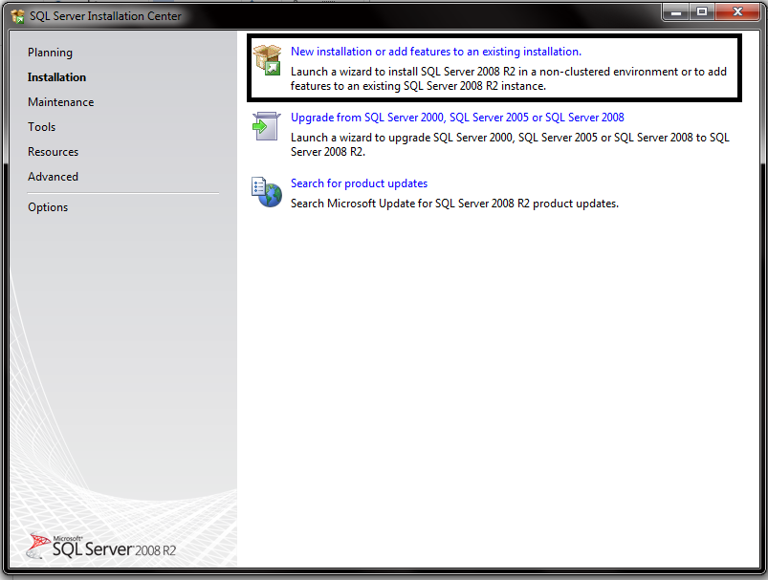

1. Click Accept Terms

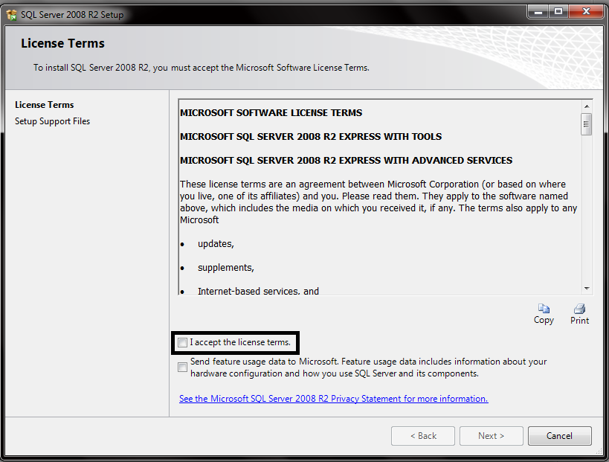

1. Select All Features , choose the feature directory place on your computer and Click next

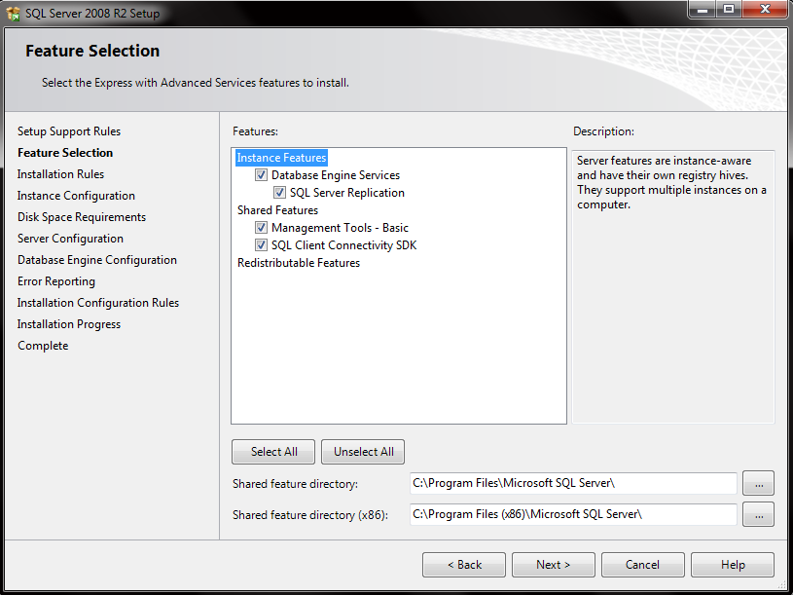

1. Write your instance name and instance ID, instance ID will be your ID at your directory file. You can’t put special character for your instance.

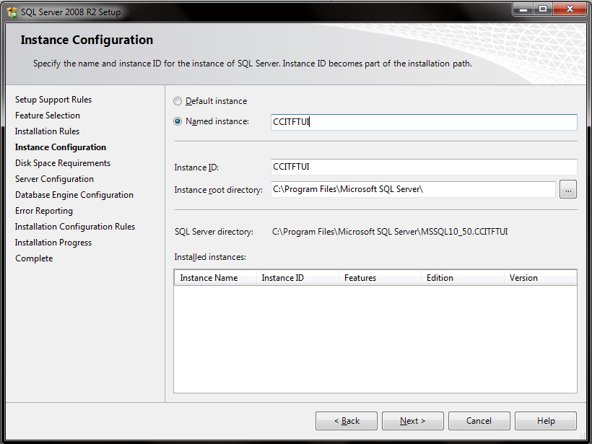

1. This is Service Account step, make sure you use separate account like Microsoft recommends. If you done, click next.

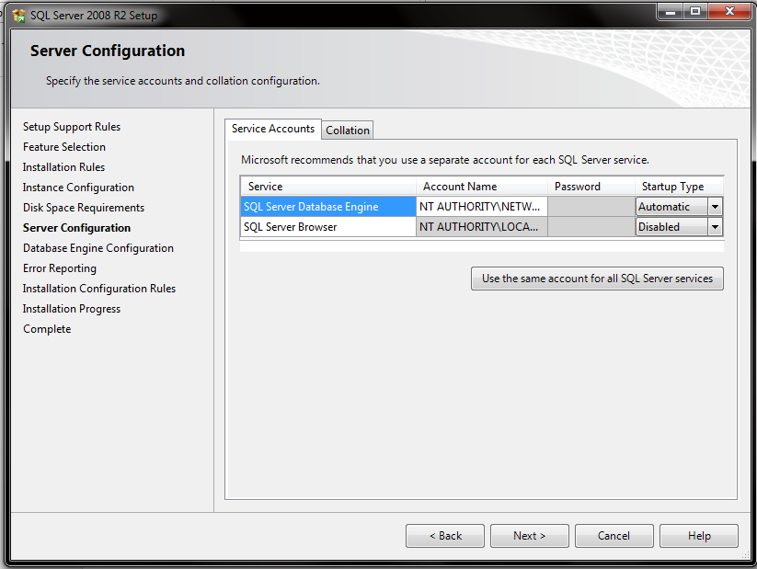

1. In this section you will choose the password for your database. Choose Windows Authentication Mode to let Windows Authenticating when you Log In to your database or make mixed password to make password by yourself. In this section you can choose the user who can use this Database Application.

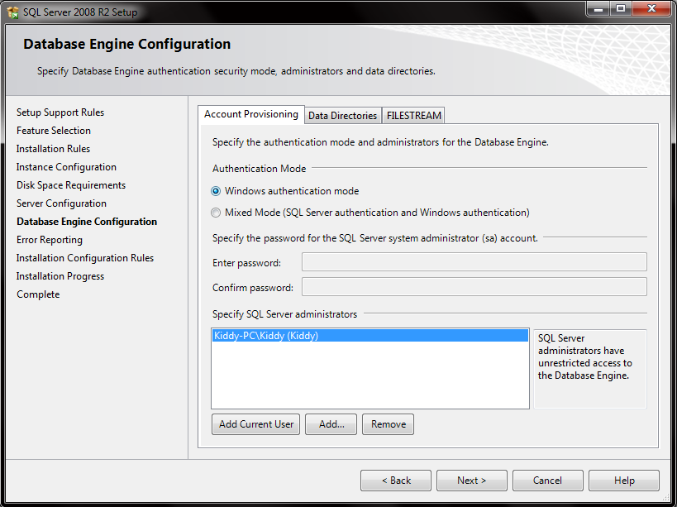

1. You can choose Send Windows Error Report to Microsoft or your Corporate Report Server if something happened to your Database.

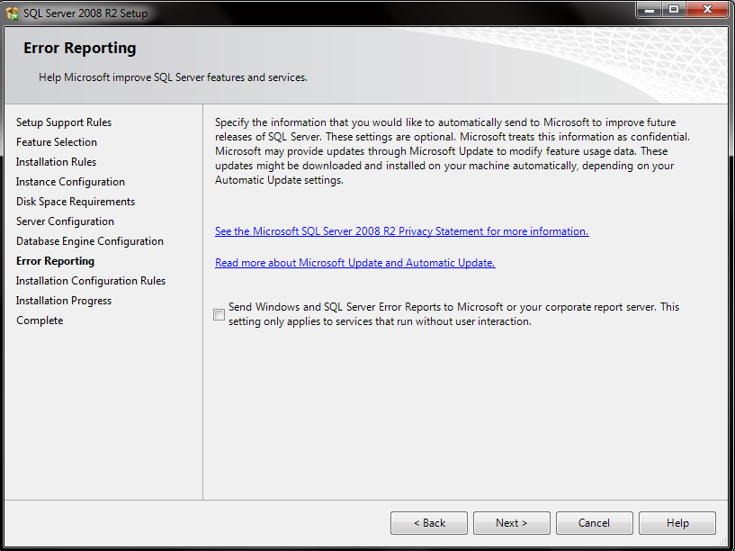

1. Please wait untill installation progress completed.

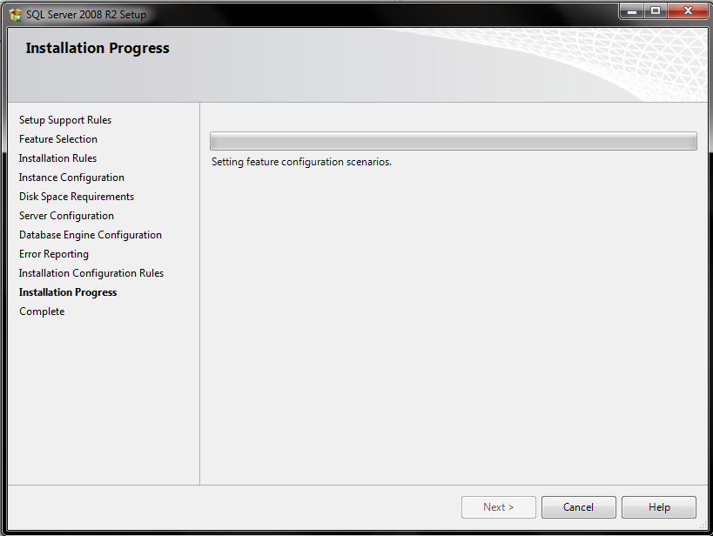

1. Click close when the installation was completed.

